|  |  |  |
| --- | --- | --- |
| **LAB101 Assignment** | **Type:** | **Short Assignment** |
| **Code:** | **C.S.P0026** |
| **LOC:** | **50** |
| **Slot(s):** | **1** |

**Title**

Convert decimal to binary numbers.

**Background**

In [mathematics](https://en.wikipedia.org/wiki/Mathematics) and [digital electronics](https://en.wikipedia.org/wiki/Digital_electronics), a binary number is a [number](https://en.wikipedia.org/wiki/Number) expressed in the binary numeral system or base-2 numeral system which represents numeric values using two different symbols: typically [0 (zero)](https://en.wikipedia.org/wiki/0_(number)) and [1 (one)](https://en.wikipedia.org/wiki/1_(number)). The [base](https://en.wikipedia.org/wiki/Radix)-[2](https://en.wikipedia.org/wiki/2_(number)) system is a [positional notation](https://en.wikipedia.org/wiki/Positional_notation) with a radix of 2. Because of its straightforward implementation in [digital electronic circuitry](https://en.wikipedia.org/wiki/Digital_electronics) using [logic gates](https://en.wikipedia.org/wiki/Logic_gate), the binary system is used internally by almost all modern [computers and computer-based devices](https://en.wikipedia.org/wiki/Computer). Each digit is referred to as a [bit](https://en.wikipedia.org/wiki/Bit).

**Program Specifications**

Design a program that allows users to input a positive integer and output the corresponding binary form.

The program should be repetitive until users close the program

***Function details:***

1. Display a screen to prompt users to input a positive decimal number.

* Users run the program, display a screen to ask users to enter a positive decimal number.
* Users input a positive decimal number. Then, perform **Function 2**.

1. Convert decimal to binary.

* The program converts the inputted decimal to corresponding binary, and returns an array containing those converted bits from left to right.
* Output bits stored in the array to the screen.

***Expectation of User interface:***

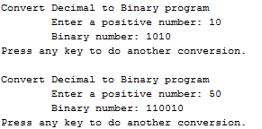

**Guidelines**

**Example: convert 11 to binary form**

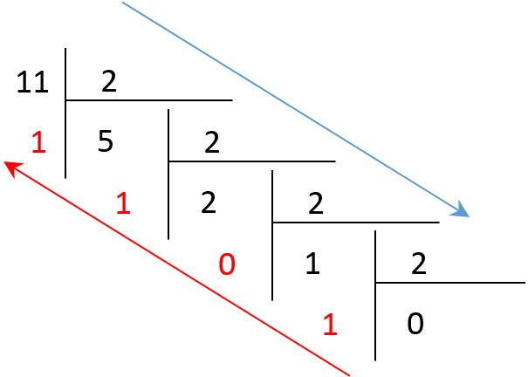

In the above division, we want to have the binary form of the decimal 11. We perform as follows:

11 divided by 2, we have remainder of 1, quotient of 5

Quotient 5 divided by 2, we have remainder of 1, quotient of 2

Repeat the process until the quotient is 0.

Then combine from bottom-up all the remainders and we have the binary form of 11

And we have the corresponding binary form of 11: 1011